**Project for scheduling in smart grids**

Arun Srikantha, Divya Pathak, Harsha Panjwani, Varun Pillai

a Department of Chemical and Biological Engineering, Drexel University

b Department of Electrical and Computer Engineering, Drexel University

c Lebow Business School, Drexel University

**Case Study**

An optimal energy scheduling policy that considers the varying demands in a particular residential neighborhood as well as minimizes the total cost is necessary in the present situation where global energy resources are limited. In this proposal an optimal strategy to schedule the running time of home appliances in a neighborhood is proposed. The random variations in the start time and running time of home appliances and the cost of delay incurred in case an equipment is scheduled for a later time are taken into account. The optimization formulation for scheduling the appliances in a single household is discussed in detail and the results are presented. Various practical constraints that an actual EMC (Electricity Management Controller) encounters during scheduling of appliances are discussed and the procedures to take this into account in the optimization formulations are described.

The Problem is briefly discussed here .The Scheduling problem is divided into 4 parts.

1. First is a base case problem or a simplified scenario which involves optimally scheduling the run time of three appliances for a single household.

2. The next part involves including the capacity constraints in the scheduling problem which restricts the amount of power available for a given household per time slot.

3. The last part asks to extend the optimization formulation to a neighborhood which involves communication between EMC’s (Electric Management Company) of nearby homes to optimally schedule the run time of appliances.

4 Development of user interface to facilitate viewing the power consumption and appliance statistics from home user perspective and the utility company’s perspective.

The Data which is used for solving the case study is as follows

**Single Home**

1 No of Appliances considered = Dish washer, Clothes dryer , Water heater.

2 Number of Time Periods (T) = 24 hours.

3 Cost of Electricity in $ /KWH for each time period is given in appendix.

4 Cost of Delay CD , Cn1 for time period <= 6 = $ 0.1.

5. Cost of Delay CD, Cn2 for time period >= 6 = $ 2.5.

6. The Probability data of an equipment being on /off in a given time period is given in the appendix.

7. Power Consumption for each appliance is 1.8 KWH.

**Neighbourhood**

1No of Homes in Neighborhood = 15.

2No of Appliances in each home = 3.

3Number of Time periods (T) = 48 hours.

4Total No of Appliances considered = 45.

5Power Consumption for each appliance in a given time period is given in Appendix.

6 Electric Cost for each appliance in a given time period is given in Appendix.

7 Cost of Delay for each time period C_n1 is as given in appendix.

8 Cost of Delay for each time period C_n2 is as given in appendix.

9 Time Periods to be considered for C_n1 is as given in appendix.

**Managerial Report**

**Executive Summary**

Energy demands in a home or across multiple homes in a neighborhood are flexible. This flexibility arises from the immediate needs of the customer to utilize various electrical appliances during the day. Primarily, electrical appliances can be categorized into two based on their utility, viz. Type I - Appliances which are required immediately for e.g. light, and Type II - Appliances which don’t have to be available the minute they are turned on for e.g. dish washer, car charger etc.

Electricity is an expensive commodity. Additionally, storing electrical power is very expensive as well. Utility companies have always faced this difficulty to maintain balance between production and utilization of electricity due to the flexible nature of utilization and the high cost of supply. The flexible nature of demand for electricity causes in grid instability and results in equipment overload, brownouts & blackouts.

This issue has led to the creation of Smart Grid technologies to be applied to the electric grid for improved transmission, distribution and customer based systems. In order to analyze the customer’s electricity utilization pattern as well as reducing the costs incurred for the flexible demands is through Smart Meters. These meters provide real-time electricity prices to homes.

Electricity prices are dictated by the demand for power during the day. Hence essentially, hours of the day which require high energy requirements in the grid are charged more. This information is also shared with the homes in each utility bill. Since this information is not shared real-time, the homes are unable to use it effectively.

Thus, our task was to create an Electricity Management Controller (EMC) which utilizes this information and effectively schedule the Type II appliances. The EMC would help plan and schedule Type II appliances and help in reducing customer’s energy costs by shifting the load to off-peak hours.

This process thus helps balance the load to maintain grid stability as well as helps in reducing energy costs of homes. Utilizing our optimizing algorithm in the EMC, a single home benefited by saving $1.16/day.

For the utility company, the EMC helps in eliminating the energy utilization peaks which were a root cause of grid instability. The EMC achieves savings for the homes while maintaining 100% service levels. The EMC thus helps the utility company not only schedule the production/supply of electricity but also in reducing expenses due to equipment overloads and blackouts.

It also improves customer satisfaction levels by enabling the utility company to provide better service.

Electricity consumption in the Unites states is projected to increase by 29% from 2012 to 2040 [*EIA*, 2015a]. The average US residential electricity prices increased at the highest rate of 3.1% since 2008 and is projected to increase by 1.0% in 2015 and by 1.8% in 2016 [*EIA*, 2015b]. It is imperative that the utility company optimizes its processes in order to meet the residential demands of a neighborhood as well as minimize the cost of electric power consumption.

Implementation of Smart grid technologies to optimize transmission & distribution in a grid is an ongoing organization strategy.

**Baseline U.S. Smart Grid Spending 2008-2017 (Historical and Forecast)**

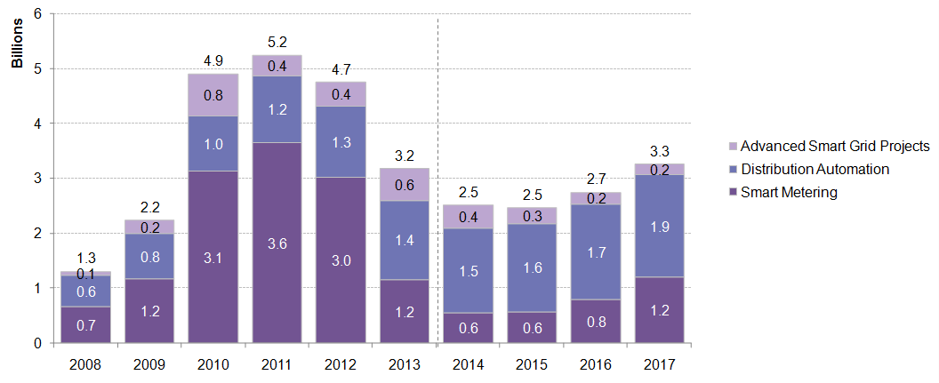

Source: BNEF 2014

We can see from the graph that major part of the spending on the Smart Grid technologies were into Smart Metering. This has resulted in installations of over 46million smart meters in the United States. Additionally, this number is estimated to reach around 65million by 2015. This accounts for over a third of the 145million meters of all types that are in use today in the United States.

A utility company’s primary source of income are from the homes and offices that exist in the grid. Although these smart grid technologies help in improving the utility company’s processes, it has still failed to include the end user as a part of its optimization process. This has triggered an interest to develop efficient strategies that minimizes the cost of electric power consumption by appropriately scheduling the run time of home appliances.

With these objectives in mind, we were tasked with the creation of an Electricity Management Controller (EMC) which utilizes information from the Smart Meters to effectively schedule the Type II appliances.

**Primary Objectives of the EMC**

* Schedule Type II Appliances in homes
* Manage power consumption and load balancing in a neighborhood

**Data Considerations**

The data provided to us contained probabilities of the utilization periods of three appliances in a single home. These appliances are primarily Type II appliances which can be scheduled and aren’t required immediately by the home owner.

We also have real-time prices of electricity obtained from Smart Meters. This basically lists price of electricity per hour. This pricing is based on past data where peak hours were identified and the same were priced higher than the off-peak hours. The price of electricity thus remains high from the 11th to the 22nd hour period while it remains low for the rest of the periods.

Our task was to analyze the customer’s electricity utilization pattern from this data and determine the costs incurred by the homeowner as a result of adhoc access of the grid.

We found that a homeowner uses 3.6 kWh /hour on an average. Additionally, this information was simulated for an entire neighborhood of 15 homes. We found that a neighborhood used 103 kWh on an average.

We also found examples where the grid became unstable during the simulation which proves that our simulation was a perfect sample of the real-time scenario. We ignored scenarios which did not produce any tangible benefits .

Our focus was primarily on analyzing scenarios which would provide benefits both to the customer as well the utility company.

**Cost Benefit Scenarios**

Figure below shows the cost benefits in scheduling the appliances for a 24 hours period by applying delay costs at peak hours.

|  |  |  |  |  |  |  |  |  |  |  |  |  |  |  |  |  |
| --- | --- | --- | --- | --- | --- | --- | --- | --- | --- | --- | --- | --- | --- | --- | --- | --- |
| |  |  |  | | --- | --- | --- | |  | Cost (W/o Scheduling) | Cost (W Scheduling ) | | Dishwasher | 0.8064 | 0.2504 | | Water Heater | 0.8064 | 0.5008 | | Clothes Dryer | 1.9152 | 1.6096 | | Total Cost | **3.528** | **2.3608** | |  |

We get optimum cost benefits when delay cost is applied for a request in the 20th hour and the appliance is scheduled in the 23rd hour with the delay cost for 3 time periods.

The above graph shows the customer request for the Dishwasher in the 21st hour for a duration of 2 hours. However, the EMC scheduled to start it at the 23rd hour. Similarly, the water heater was requested at the 19th hour and 22nd hour for a duration of one hour and the clothes dryer was requested at the 19th hour for 2 hours. The EMC scheduled the clothes dryer to run at the 23rd hour instead.

EMC scheduling for the three appliances towards off-peak hours generated savings of $1.17/day for a single home.

The graph below explains the benefit we receive when we apply delay cost to schedule appliances towards non-peak hours. The ideal time period to reschedule the appliance from the simulations for a single home with delay costs applied would be for requests between 20th and 22nd hour with a maximum delay of 3 hours.

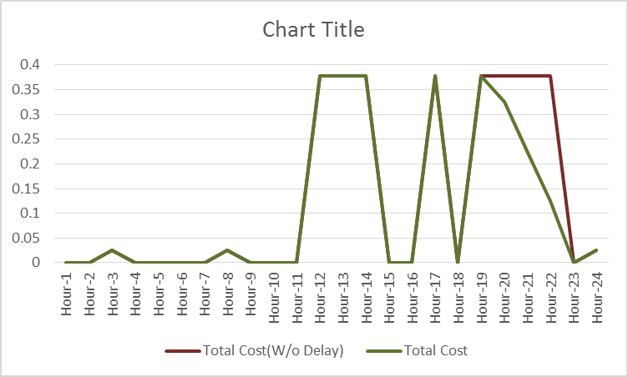

Similar to the single home scheduling, the neighborhood data was analyzed. This data considered 15homes. We ran simulations based on this data for the neighborhood and found that the appliances could be categorized further based on the duration it runs. This enables us to prioritize appliances and schedule appliances which run longer towards end of the 48 hour period we consider in the neighborhood scheduling.

Neighborhood scheduling helps maintain a level load across the power grid.

For our utility company, this has resulted in eliminating cases where the grid became unstable. This helps in eliminating the expenses caused due to equipment overload.